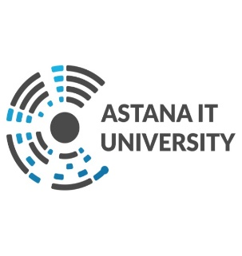**Endterm project**

Customer Relationship Management

Sapiulla Rakhymzhan

Raiymbekov Nurislan

CS-2009

**Nur-Sultan, 2021**

**Team description:**

Our team consists of two students, Nurislam Raiymbekov and Rakhimzhan Sapiulla.

**Link to Github:** <https://github.com/rsapiu11a/EndtermProject>

**ER diagram:**